**Reading inputs and storing it in 6 arrays**

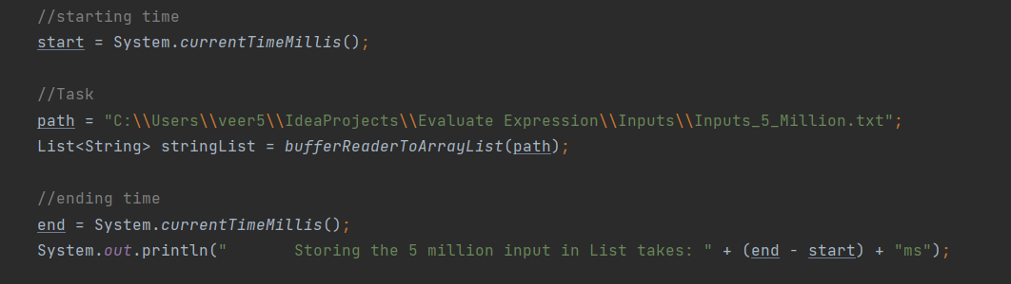

**Output:**

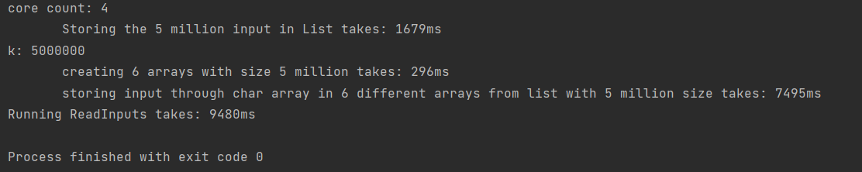

core count: 4

Storing the 5 million input in List takes: **1679ms**

k: 5000000

creating 6 arrays with size 5 million size takes: **296ms**

storing input through char array in 6 different arrays from list with 5 million size takes: **7495ms**

Running ReadInputs takes: **9480ms**

**Final Program(Single Threading) Output:**

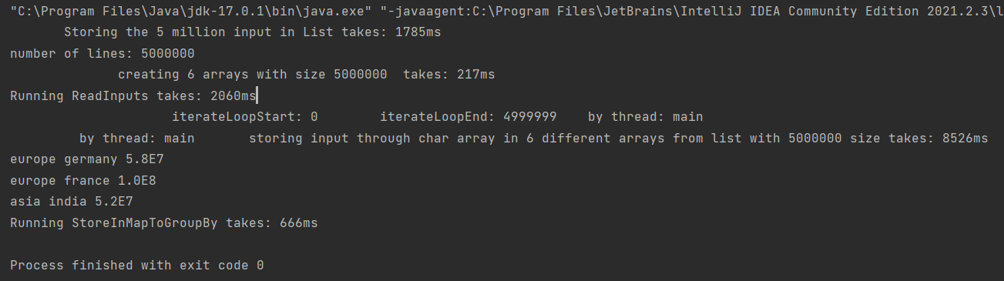

Storing the 5 million input in List takes: **1785ms**

number of lines: 5000000

creating 6 arrays with size 5000000 takes: **217ms**

Running ReadInputs takes: **2060ms**

iterateLoopStart: 0 iterateLoopEnd: 4999999 by thread: main

by thread: main storing input through char array in 6 different arrays from list with 5000000 size takes: **8526ms**

**europe germany 5.8E7**

**europe france 1.0E8**

**asia india 5.2E7**

Running StoreInMapToGroupBy takes: **666ms**

**Output by using Multithreading**

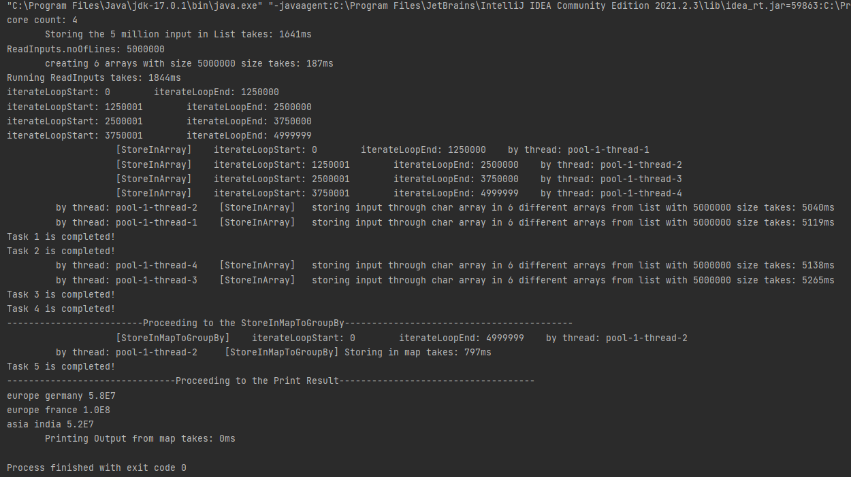

core count: 4

Storing the 5 million input in List takes: **1641ms**

ReadInputs.noOfLines: 5000000

creating 6 arrays with size 5000000 size takes: **187ms**

Running ReadInputs takes: **1844ms**

iterateLoopStart: 0 iterateLoopEnd: 1250000

iterateLoopStart: 1250001 iterateLoopEnd: 2500000

iterateLoopStart: 2500001 iterateLoopEnd: 3750000

iterateLoopStart: 3750001 iterateLoopEnd: 4999999

[StoreInArray] iterateLoopStart: 0 iterateLoopEnd: 1250000 by thread: pool-1-thread-1

[StoreInArray] iterateLoopStart: 1250001 iterateLoopEnd: 2500000 by thread: pool-1-thread-2

[StoreInArray] iterateLoopStart: 2500001 iterateLoopEnd: 3750000 by thread: pool-1-thread-3

[StoreInArray] iterateLoopStart: 3750001 iterateLoopEnd: 4999999 by thread: pool-1-thread-4

by thread: pool-1-thread-2 [StoreInArray] storing input through char array in 6 different arrays from list with 5000000 size takes: **5040ms**

by thread: pool-1-thread-1 [StoreInArray] storing input through char array in 6 different arrays from list with 5000000 size takes: **5119ms**

Task 1 is completed!

Task 2 is completed!

by thread: pool-1-thread-4 [StoreInArray] storing input through char array in 6 different arrays from list with 5000000 size takes: **5138ms**

by thread: pool-1-thread-3 [StoreInArray] storing input through char array in 6 different arrays from list with 5000000 size takes: **5265ms**

Task 3 is completed!

Task 4 is completed!

-------------------------Proceeding to the StoreInMapToGroupBy------------------------------------------

[StoreInMapToGroupBy] iterateLoopStart: 0 iterateLoopEnd: 4999999 by thread: pool-1-thread-2

by thread: pool-1-thread-2 [StoreInMapToGroupBy] Storing in map takes: **797ms**

Task 5 is completed!

-------------------------------Proceeding to the Print Result------------------------------------

**europe germany 5.8E7**

**europe france 1.0E8**

**asia india 5.2E7**

Printing Output from map takes: **0ms**